DICT; built from CSTWS_BEFORE & CSTWS_AFTER

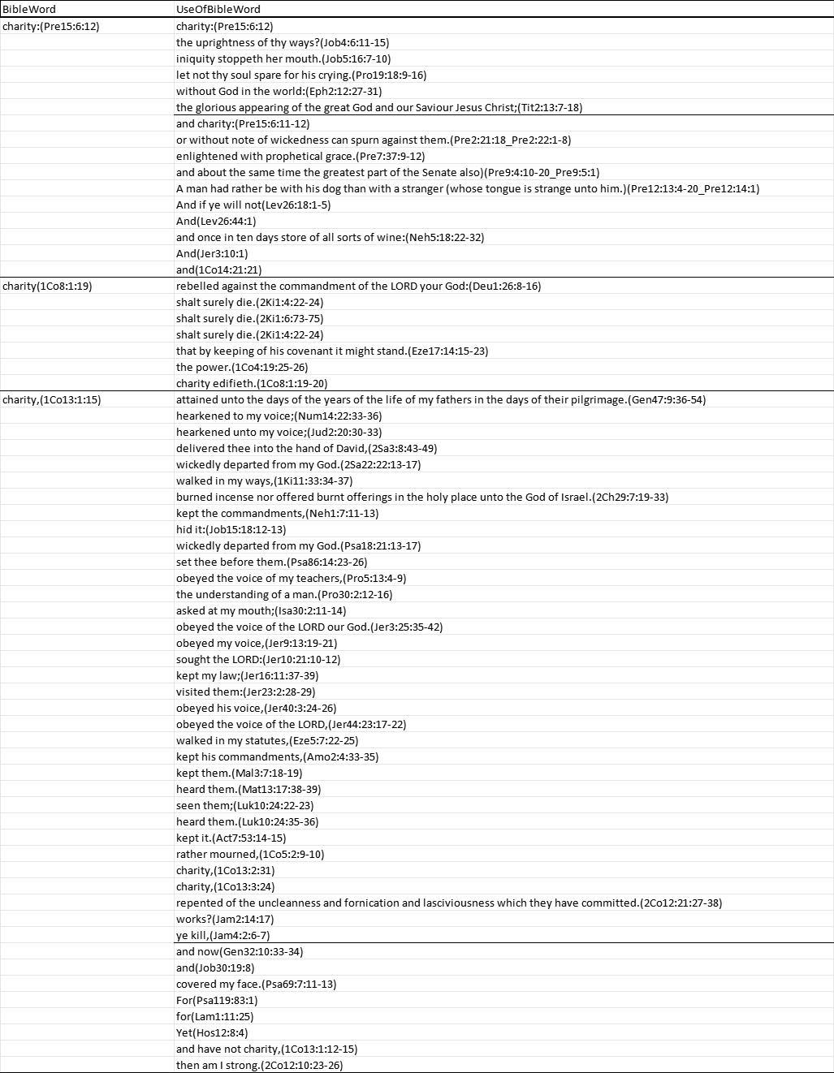

LIMIT TABLE
